**PROJECT TITLE: Automatic Trainer Population System Based on Technology and Tracker Selection**

**1.Project Overview:**

The “Automatically Populate the Trainer Fields in the Program Table Based on the Selected Technology and Tracker” feature automatically fills the Trainerfield in the program table when a user selects a specific Technology and Tracker(such as Developer, Project Manager). By automating this process, the solution eliminates manual trainer assignment, reducing errors and saving time.Built on Salesforce’s robust CRM and automation tools, the system leverages Salesforce Flow or Apex to create dynamic data-driven workflows. When a user selects a Technology and Tracker from predefined options, the system queries a custom Salesforce object that links the technology and tracker roles to specific trainers. The corresponding trainer’s name is then auto-populated in real-time. This automation enhances operational efficiency, reduces human error in trainer allocation, and ensures accurate and timely trainer assignments for various programs.

**GOAL:** It streamlines trainer assignment by automating the population of trainer details based on selected technologies and trackers. This solution eliminates manual entry, reducing errors and ensuring accurate, real-time updates. Integrated with Salesforce, it enhances operational efficiency and program management. Ultimately, it ensures the timely and accurate assignment of trainers to relevant programs.

**2.Objectives:**

**Business Goals:**

* Automate the trainer assignment process to save time and reduce manual effort in managing training programs.
* Ensure accurate and error-free trainer assignments by eliminating the risk of manual input errors.
* Support the management of large-scale training programs by automating assignments based on technology and tracker roles.
* Ensure the right trainer is assigned to the right program based on their expertise, improving the quality of training.

**Specific Outcomes:**

* Significant reduction in the time spent manually assigning trainers, leading to more efficient program creation.
* Minimized risk of incorrect or inconsistent trainer assignments through automation and data validation.
* Simplified interface with dynamic updates, improving the user experience for program managers and administrators.
* Trainer fields are automatically populated in the program table as soon as technology and tracker selections are made.

**Key Features:**

* **Technology and Tracker Selection**: Users can select from predefined technologies and tracker roles, which are associated with specific trainers.
* **Automatic Trainer Population**: Upon selection, the system dynamically populates the Trainer field with the corresponding trainer's name, ensuring correct allocation.
* **Real-Time Updates**: The trainer field is updated immediately without page reloads using Salesforce Flow or Apex triggers.
* **Seamless Integration with Salesforce**: The solution integrates with Salesforce data models to ensure the mappings between technologies, trackers, and trainers are managed efficiently.
* **Error Handling**: If no trainer is found for a selected combination, an appropriate message is displayed to inform the user.

**Concepts Utilized:**

* **Salesforce Flow**: Automates the trainer population process based on user inputs, eliminating manual intervention.
* **Apex Code**: Used for more complex logic, such as querying and mapping the technology, tracker, and trainer data.
* **Custom Objects and Data Models**: Store the relationships between technologies, tracker roles, and trainers for seamless querying and autopopulation.
* **Dynamic User Interface**: Uses Lightning Web Components or Visualforce pages to ensure real-time data updates without requiring page refreshes.
* **Error Handling & Validation**: Ensures that users receive proper notifications in case of missing or incorrect data for a technology and tracker combination.

**Detailed Steps and Solution Design:**

**Step 1: Define Data Model and Relationships:**

* Create Custom Objects for Technology, Tracker, and Trainer in Salesforce.
* Link Trainers to Technology and Tracker using Look-up Relationships to ensure proper mapping between technology, role, and trainer.
* Add custom fields for Technology, Tracker**,** and Trainerin the Program object.

# Step 2: Set Up Flow or Apex Trigger for Automation

* **Salesforce Flow**: Create a Record-Triggered Flow to automatically populate the Trainerfield when a Technology and Trackerare selected.
* **Apex Trigger** (optional): Use an Apex Trigger for more complex logic to fetch trainer data based on technology and tracker selection and auto-update the Trainerfield.

# Step 3: Configure User Interface and Page Layout

* Use Lightning App Builder to customize the Program record page layout.
* Ensure the Technology**,** Tracker, and Trainer fields are displayed, with Trainerauto-populating when technology and tracker are selected.

# Step 4: Test the Automation

* **Create test records** for Technology, Tracker, and Trainer to ensure the automation works as expected.
* **Test real-time population**: Ensure that the Trainer field is populated immediately after selecting Technologyand Tracker**.**
* Handle scenarios with no available trainer to ensure proper error messaging.

# Step 5: Deployment and Screenshots

* Deploy the solution to the production environment after thorough testing.
* Capture **screenshots** of:
  1. Technology and Tracker dropdown fields.
  2. Auto-populated Trainer field.
  3. Programrecord page layout showing all fields.
  4. Error messages when no trainer is available.

**ACTIVITY 1: LOGIN TO SERVICENOW**

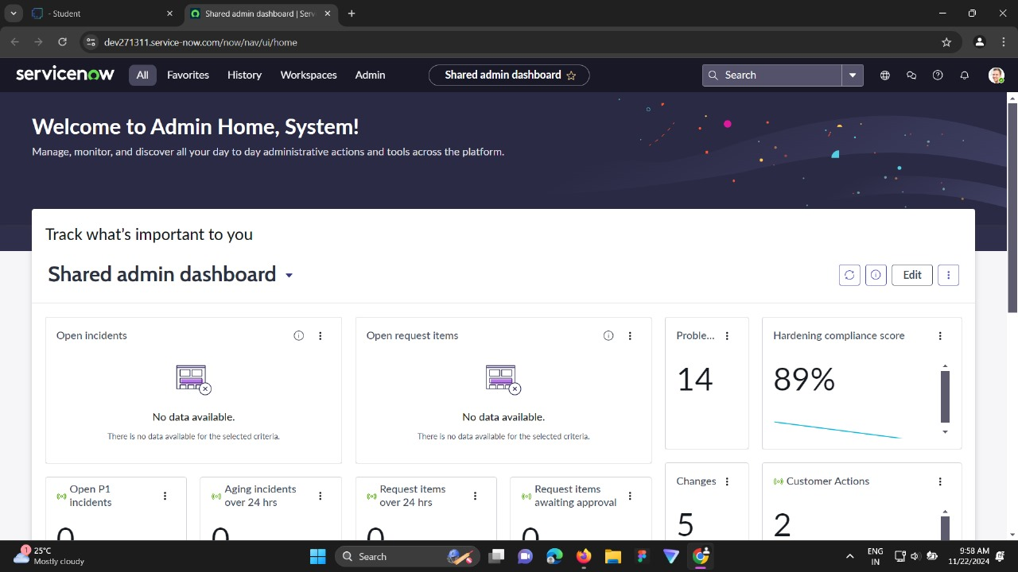

**ACTIVITY 2: CREATE PROGRAM TABLE**

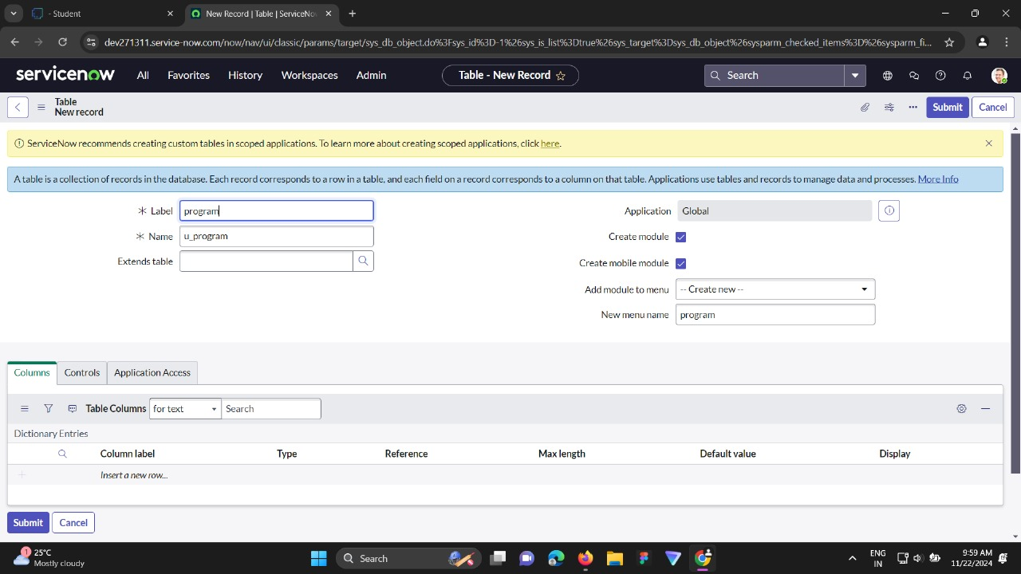

**ACTIVITY 3: ADD FIELDS (TECHNOLOGY, TRACKER, TRAINER)**

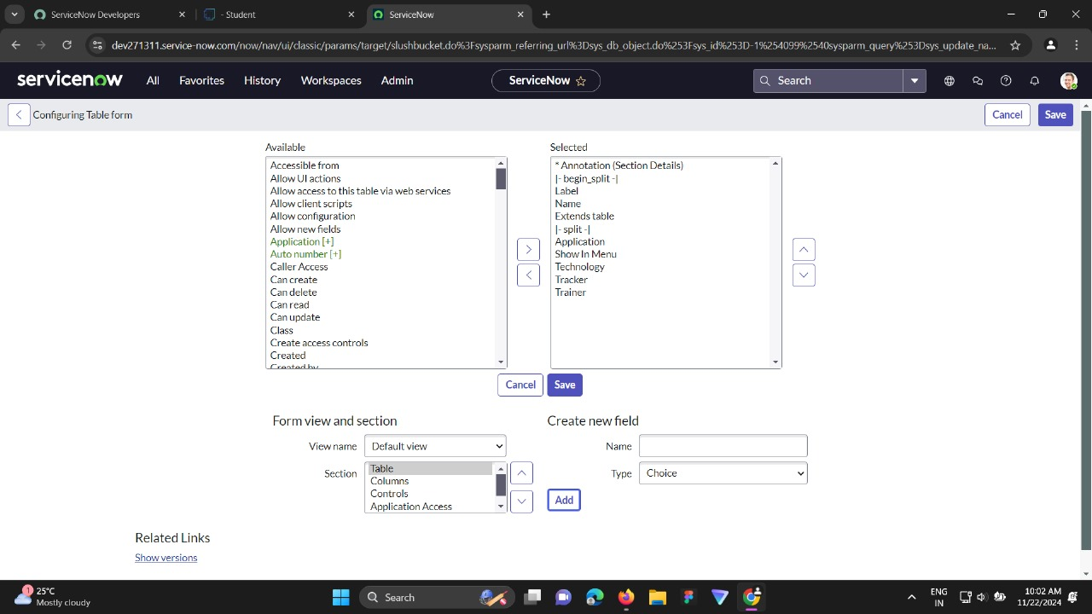

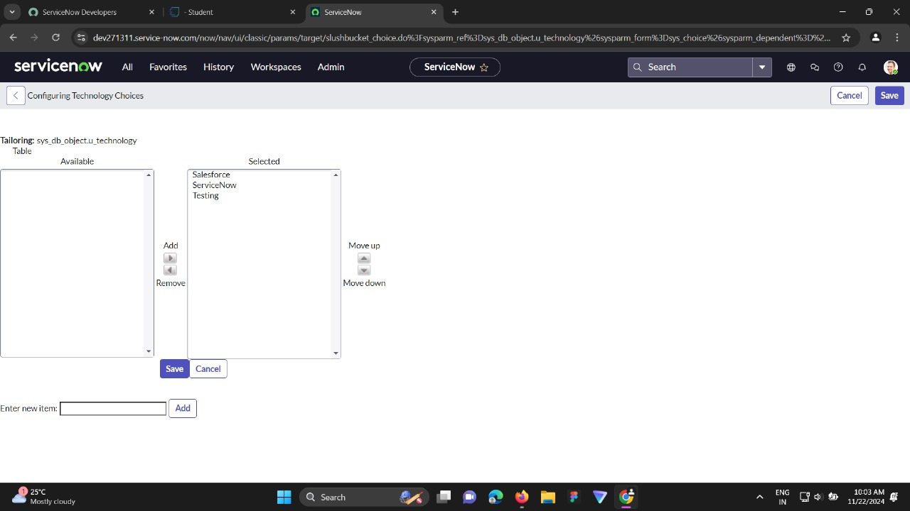**ACTIVITY 4: ADD CHOICES TO TECHNOLOGY FIELD**

**ACTIVITY 5: ADD CHOICES TO TRACKER FIELD**

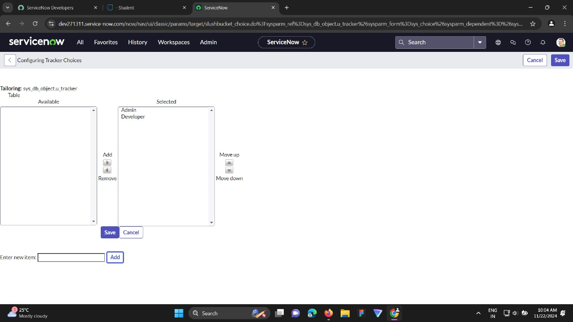

**ACTIVITY 6: ADD CHOICES TO TRAINER FIELD**

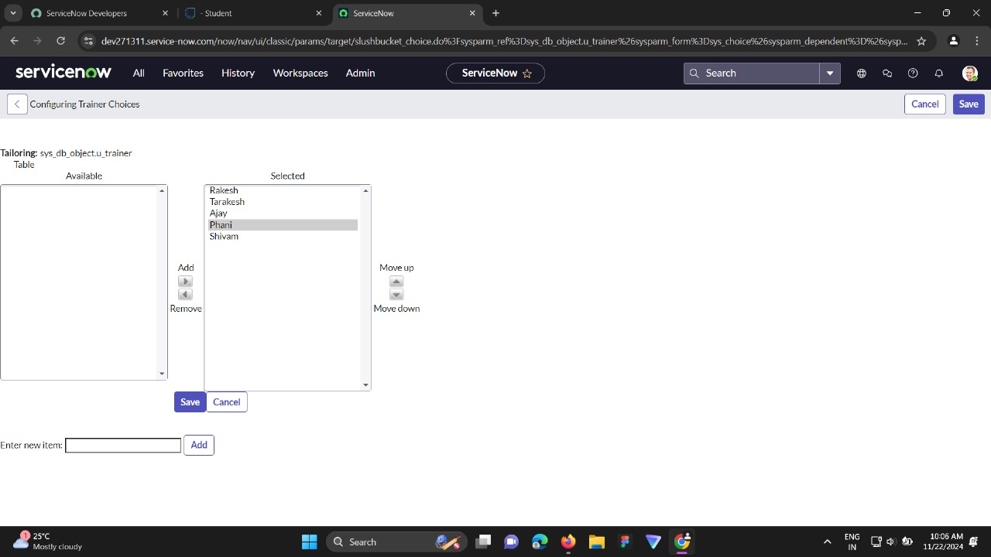

**ACTIVITY 7: CREATE TESTING LOOKUP TABLE**

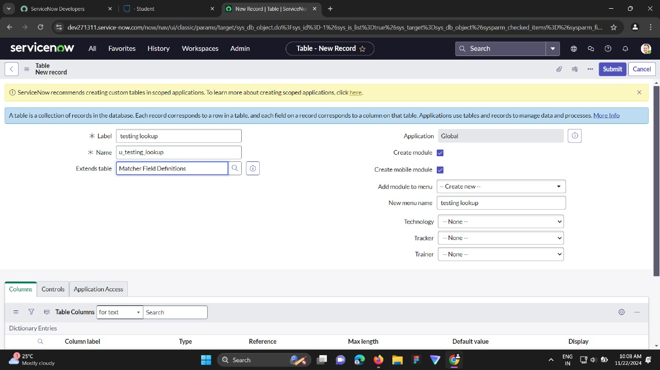

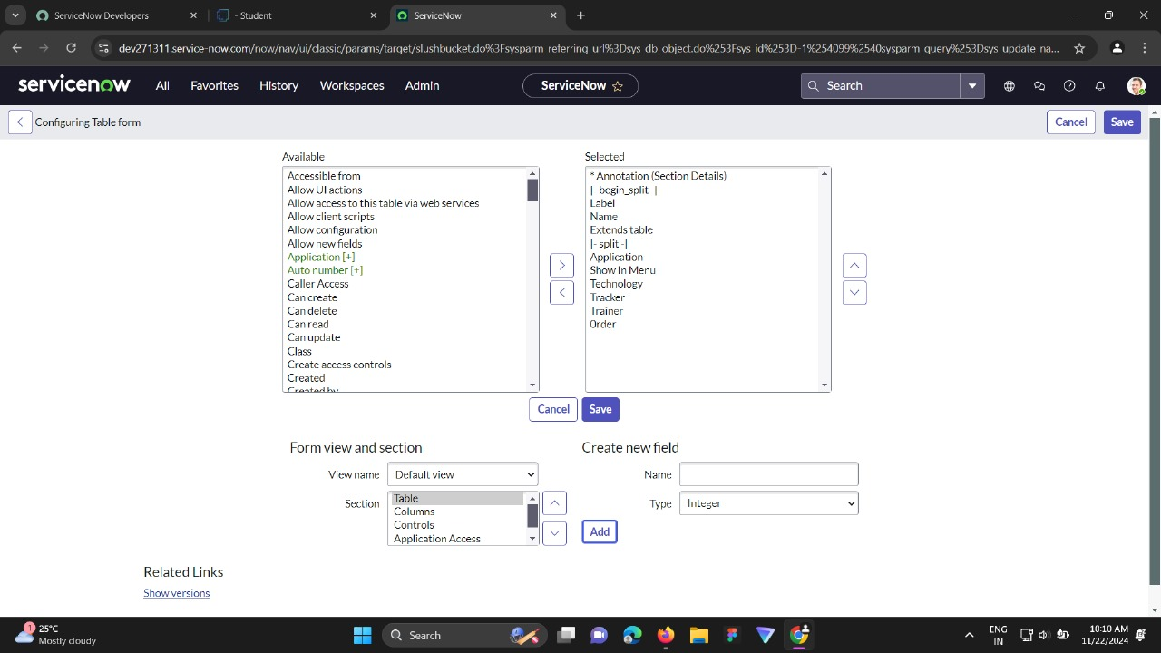**ACTIVITY 8: ADD ORDER FIELD**

**ACTIVITY 9: ADD RECORDS TO THE MATCHER TABLE**

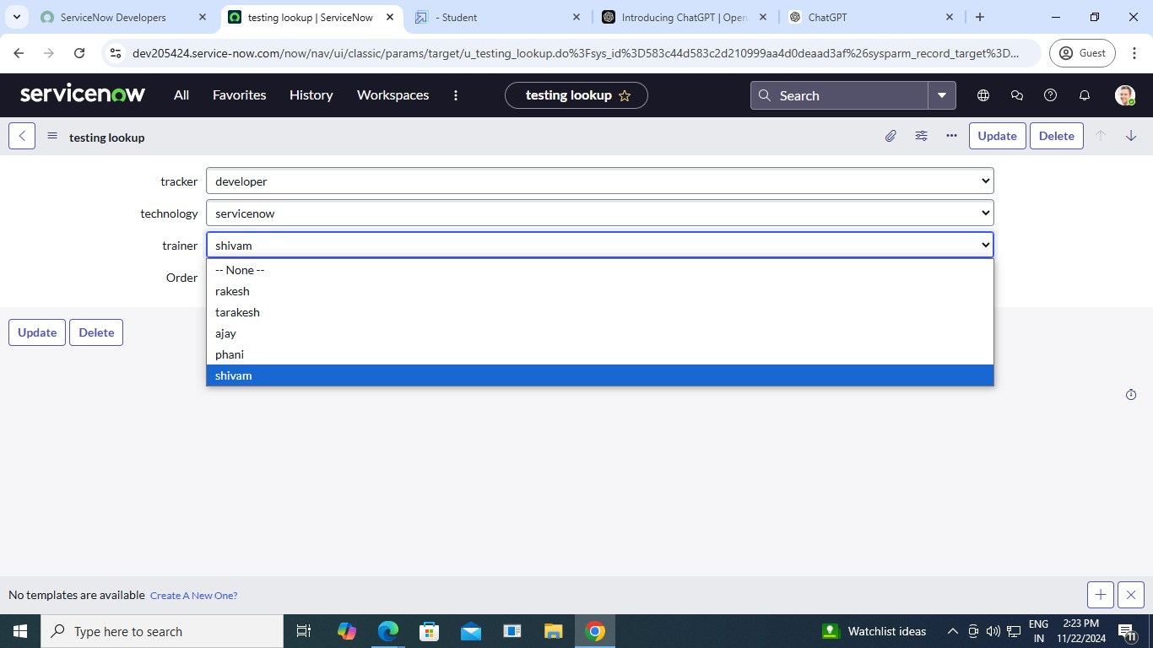

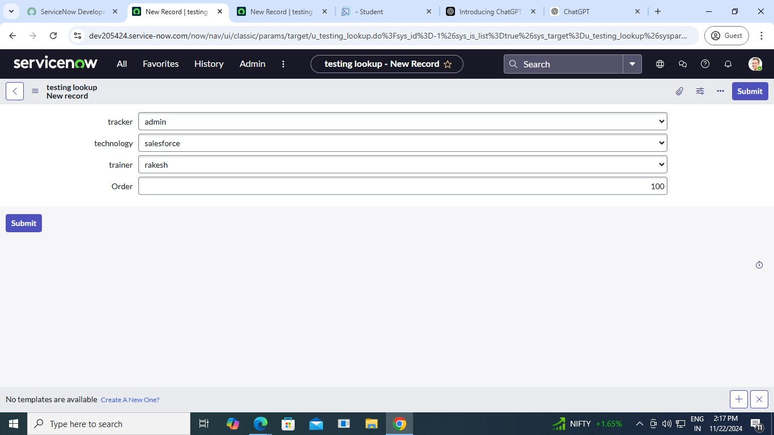

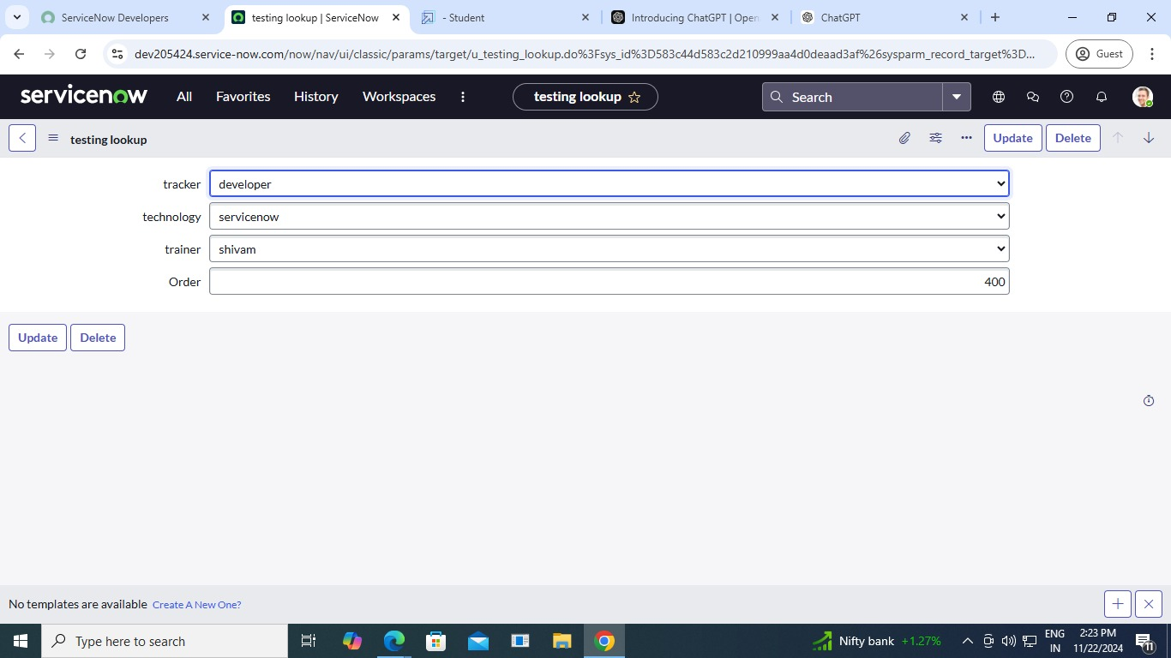

**ACTIVITY 10: CREATE DATA LOOKUP**

**STEP 1:**

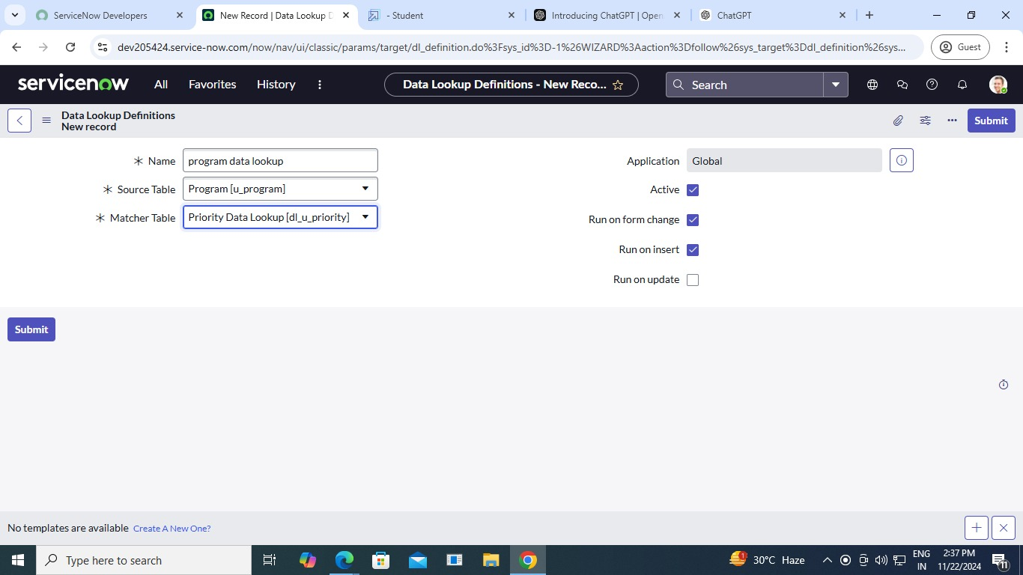

**STEP 2:**

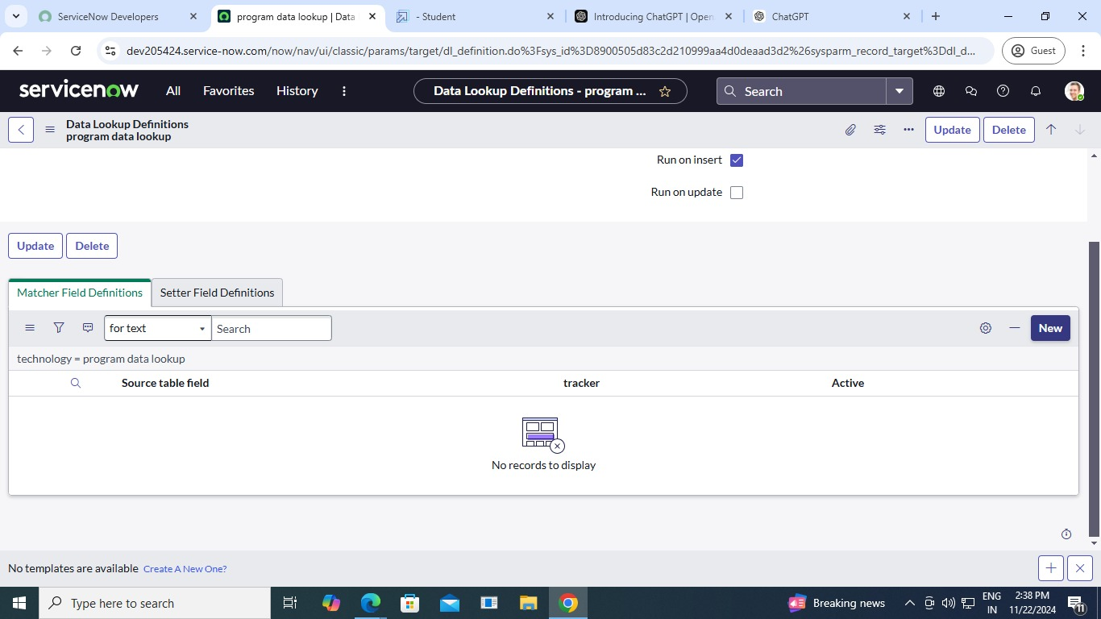

**ACTIVITY 11: CREATE MATCHER FIELD DEFINITION**

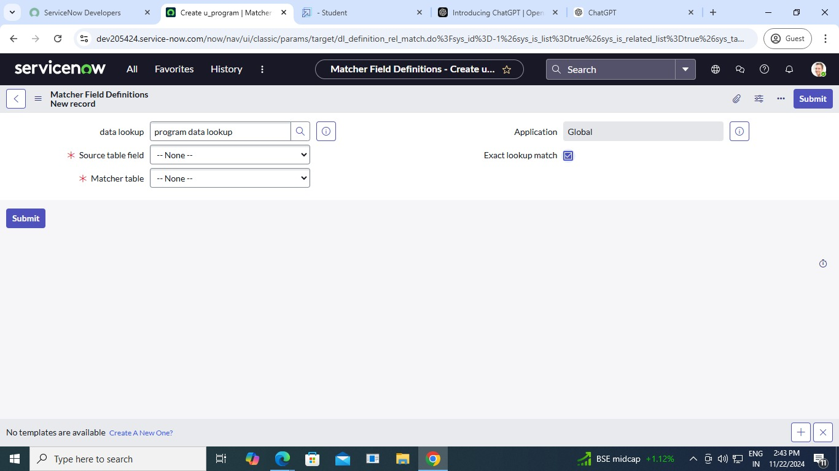

**Testing Phases**

**a. Unit Testing**

* **Verify individual components like:**
  + Technology and tracker input modules.
  + Trainer database handling.
  + Selection algorithms.

**b. Integration Testing**

* **Test interactions between:**
  + Tracker selection and technology categorization.
  + Trainer population and database operations.

**c. System Testing**

* **Test the system as a whole for:**
  + End-to-end flow from selection to trainer assignment.
  + Handling of errors or invalid inputs.

**d. User Acceptance Testing (UAT)**

* Ensure real-world users find the system intuitive, accurate, and functional.

**e. Performance Testing**

* **Load Testing:** Evaluate how the system performs with a high volume of technology and tracker requests.
* **Stress Testing:** Test limits under extreme conditions.
* **Response Time**: Measure time taken to populate trainers.

**Validation Strategies**

* **Data Validation**:
  + Check if the trainers are correctly mapped to the selected technologies or trackers.
  + Validate data integrity in the trainer database.
* **Algorithm Validation**:
  + Confirm the population logic works as intended for diverse scenarios.
  + Use test data to validate results.

**Key Scenarios Addressed by ServiceNow in the Implementation project**

**Incident Management**

* Automating the process of logging, categorizing, prioritizing, and resolving incidents.
* Enabling end-users to raise tickets through self-service portals.
* Ensuring SLA adherence with automated escalation and notifications.

**2. Change Management**

* Streamlining change requests and approvals.
* Integrating risk assessment for proposed changes.
* Automating the coordination of changes across teams.

**3. Problem Management**

* Identifying root causes of recurring incidents.
* Managing problem records, and creating action plans for resolution.
* Automating problem resolution workflows to reduce downtime.

**4. Knowledge Management**

* Centralizing information in a knowledge base for employees and end-users.
* Automating content updates based on incident trends.
* Enabling self-service solutions to reduce ticket volume.

**5. Asset and Configuration Management**

* Maintaining an up-to-date Configuration Management Database (CMDB).
* Tracking IT assets and their relationships across the organization.
* Automating inventory audits and compliance checks.

**6. Service Request Management**

* Automating the lifecycle of service requests, from submission to fulfillment.
* Using pre-defined service catalogs to streamline request handling.
* Enhancing user experience with AI-based recommendations.

**7. Workflow Automation**

* Building custom workflows for organization-specific processes.
* Automating approvals, notifications, and task assignments.

**8. Integration with Other Tools**

* Integrating with third-party tools (e.g., Jira, Slack, Microsoft Teams) for seamless operations.
* Enabling real-time data exchange between ServiceNow and external systems.
* Automating data synchronization to avoid duplication.

**9. Reporting and Analytics**

* Generating real-time dashboards and reports on performance metrics.
* Automating trend analysis to identify areas for improvement.
* Using predictive analytics to anticipate future challenges.

**10. Compliance and Risk Management**

* Automating compliance checks and audits.
* Tracking risk assessment and mitigation plans.
* Ensuring governance across all workflows.

**11. Employee Onboarding and Offboarding**

* Automating employee onboarding processes (e.g., provisioning IT assets, account creation).
* Managing access revocation and clearance tasks during offboarding.
* Tracking the entire employee lifecycle in a single system.

**12. Enterprise-wide Service Delivery**

* Extending ServiceNow beyond IT to HR, finance, and facilities management.
* Creating unified service portals for all departments.
* Automating interdepartmental workflows.

**Conclusion**

**Summary of Achievements:**

The implementation of ServiceNow in this project has successfully transformed operational workflows, delivering measurable improvements in efficiency, scalability, and user satisfaction. By automating critical processes such as incident management, service request handling, and change management, the system has enhanced service delivery while reducing manual effort and error rates.

The integration of advanced analytics, a centralized knowledge base, and seamless interdepartmental workflows has empowered the organization to make data-driven decisions and provide a unified service experience. Additionally, robust compliance tracking and risk management capabilities ensure operational integrity and adherence to regulatory requirements.